Prepared for:

**Federal Communications Commission**

**CMS Alliance to Modernize Healthcare**  
**Federally Funded Research and Development Center**

**Contract No. 75FMC18D0047**

**Task Order No. 273FCC19F0144**

ACE Direct Platform Release Documentation

User Guide

Version 4.0

July 1, 2020

The views, opinions, and/or findings contained in this report are those of The MITRE Corporation and should not be construed as official government position, policy, or decision unless so designated by other documentation.

Approved for Public Release; Distribution Unlimited. Case Number 20-1580.

© 2020 The MITRE Corporation. All rights reserved.

Record of Changes

| Version | Date | Author / Owner | Description of Change |
| --- | --- | --- | --- |
| 1.0 | November 4, 2016 | The Health FFRDC | Version 1.0 for release to Sponsor |
| 1.1 | February 17, 2017 | The Health FFRDC | Version 1.1 for release to Sponsor |
| 2.0 | November 1, 2017 | The Health FFRDC | Version 2.0 for release to Sponsor |
| 2.1 | May 24, 2018 | The Health FFRDC | Version 2.1 for release to Sponsor |
| 3.0 | October 26, 2018 | The Health FFRDC | Version 3.0 for release to Sponsor |
| 3.1 | April 9, 2019 | The Health FFRDC | Version 3.1 for release to Sponsor |
| 4.0 | July 1, 2020 | The Health FFRDC | Version 4.0 for release to Sponsor |

1. Executive Summary

The Federal Communications Commission (FCC) Telecommunications Relay Service (TRS) Center of Expertise (COE) Project promotes the Commission’s goal to foster innovations that advance functionally equivalent telecommunications. Toward that end, the project ensures that the TRS employs improved technology for persons who are d/Deaf,[1] hard of hearing, DeafBlind, and/or have speech disabilities. The FCC has embraced a research-based approach to achieve this goal by engaging the Health Federally Funded Research and Development Center (Health FFRDC), operated by The MITRE Corporation (MITRE), to conduct independent engineering assessments that promote and demonstrate TRS’s functional equivalence.

The Health FFRDC is independently assessing voice telephone services, video access services, and Internet Protocol (IP)-based captioning technology; improvements to TRS efficiency; solutions for direct communication between people with communication disabilities and other telephone users; and the effectiveness, efficiency, and consumer response to current and future approaches for delivering TRS.

At the FCC’s request, the Health FFRDC developed a Direct Video Calling (DVC) Auto-Routing Proof of Concept (POC) in support of the FCC’s Accessible Communications for Everyone (ACE)[2] program. This DVC auto-routing platform enables direct calling from d/Deaf or hard of hearing individuals to an American Sign Language (ASL)-trained agent within the organization’s call center. The agent handles the call using a video-capable phone with real-time video connection. To demonstrate the capabilities of DVC, the FCC and the Health FFRDC have further advanced the original auto routing POC into a call center platform for 2 to 20 Agents. This new DVC platform is called ACE Direct.

Implementing the Direct Video Calling platform provides critical benefits toward achieving functionally equivalent telecommunications:

* **Improved Communications** – DVC improves privacy and decreases misrepresentation, which improves efficiency, effectiveness, and productivity.
* **Career Opportunities** – Employing native ASL users to handle customer service video calls expands hiring opportunities. Executive Order 13548 (July 2010) directed federal agencies to increase employment opportunities for people with disabilities.
* **Simple Implementation** – The technology to implement a DVC system is readily obtainable, affordable, and easy to set up.
* **Secure Communications** – With proper configuration, agencies can use high-speed broadband and their own internal networks without compromising security or contending with barriers created by firewalls.
* **Maintain ADA Compliance** – DVC ensures compliance mandated by the Americans with Disabilities Act.
* **Cost Savings** – Replacing three-way interpreted calls with two-way direct communication saves money by minimizing the need for repeat calls due to miscommunication and/or misunderstanding.

As part of this effort, the Health FFRDC developed and documented requirements and features, including user stories and associated use cases. The Health FFRDC also configured, tested, and integrated provider endpoint video devices with the ACE Direct platform. Detailed configuration and source code files are available for download and reproduction to improve solutions to support the community. The public can download or clone these files at <https://github.com/FCC/ACEDirect>.

This version of ACE Direct includes the following new features:

* **Captioning** – Automated Speech Recognition engine speech-to-text captioning is now available in the Consumer and Agent portals.
* **WebRTC Media Server** – ACE Direct now uses a Kurento WebRTC Media Server to enhance and improve ACE Direct’s voice, video, and data capabilities.
* **Videomail Enhancement** – The media server implements higher quality videomail recordings, Interactive Video and Voice Response, and a countdown timer.
* **Containerization** – Open AM and Asterisk are now available as Docker containers.
* **Agent, Consumer and Management Portal User Interface Enhancements** – The web portals have better aspect ratios for video, element locations, element placement, and button sizing.
* **Multi-Party Calling –** ACE Direct Agents and Consumers can participate in calls with up to four simultaneous callers on the same call.
* **Screen Sharing** – ACE Direct users can allow the caller to share their screen with another caller.
* **File Sharing** – ACE Direct users can share or transfer files from one user to another.

Table of Contents

1. Introduction 1

1.1 Background 1

1.2 Purpose and Scope 2

2. Overview of Direct Video Calling and ACE Direct 3

2.1 DVC Is an Alternative to Traditional Relay Calls 3

2.2 Open Source Development to Promote Community Involvement 3

2.3 Conceptual System Overview 3

2.4 ACE Direct Components and Technology Features 6

2.5 Highlighted User Stories 11

2.6 Agent Desktop 13

2.6.1 Logging into ACE Direct 13

2.6.2 Side Panels 14

2.6.3 Video and Real-Time Text Communications 22

2.6.4 Agent Portal Header 24

2.6.5 Video Relay Service 25

2.7 Kuando Busylight™ Visual Ring Indicator and Agent Status 26

2.7.1 Agent Status 26

2.7.2 Kuando Busylight™ Light Configuration 26

2.7.3 Lightserver 27

2.8 Consumer Help Center 28

2.8.1 Submit a Complaint 29

2.8.2 Use Real-Time Text Chat 31

2.8.3 Leave a Videomail 32

2.8.4 Consumer Multi-Party Calls 33

2.8.5 Consumer Screen Sharing 33

2.8.6 Consumer File Sharing 34

2.9 Management Portal 35

2.9.1 Management Dashboard 35

2.9.2 CDR Dashboard 37

2.9.3 Videomail Dashboard 39

2.9.4 Hours of Operation 40

2.9.5 Agent Management 40

2.10 Identity and Access Management 42

2.10.1 Login Screen 43

2.10.2 User Dashboard 45

2.11 Data Logger 48

2.11.1 Login Screen 49

2.11.2 Session Manager 50

2.11.3 Matrix View 54

Acronyms 56

Notice 58

List of Figures

Figure 1. Notional Diagram for ACE Direct Platform 4

Figure 2. Screenshot of Agent Desktop Login 13

Figure 3. Screenshot of Agent Desktop 14

Figure 4. Screenshots of the Agent Statuses 14

Figure 5. Dialpad for Outbound Calling 15

Figure 6. Caption Settings 15

Figure 7. Screenshot of Agent Option for Multi-Party Call 16

Figure 8. Screenshot of an Agent Multi-Party Call 16

Figure 9. Screenshot of an Agent Screenshare Option 17

Figure 10. Screenshot of Agent Screen Sharing 17

Figure 11. Screenshot of Agent Sending Files 18

Figure 12. Screenshot of Agent Selecting Download File Option 19

Figure 13. Screenshot of Agent Download File Option 19

Figure 14. Screenshot of Agent Right Panel 20

Figure 15. Screenshot of Agent Status 20

Figure 16. Screenshot of Agent Videomail Mailbox 21

Figure 17. Screenshot of Videomail Playback 22

Figure 18. Screenshot of Full Screen Video Mode 23

Figure 19.Screenshot of Sample Captioning on the Agent Portal 23

Figure 20. Screenshot of User Chat Box 24

Figure 21. Screenshot of Call Duration and Assistance Button 24

Figure 22. Screenshot of Agent Profile 25

Figure 23. Screenshot of VRS Information 25

Figure 24. Screenshot of Kuando Busylight™ Light Configuration Page 27

Figure 25. Screenshot of Kuando Busylight™ Default Color Scheme 27

Figure 26. Lightserver GUI 28

Figure 27. Screenshot of Consumer Help Center 29

Figure 28. Screenshot of Consumer Complaint Form 29

Figure 29. Screenshot of Video Chat Window 30

Figure 30. Screenshot of Sample Captions on the Consumer Portal 31

Figure 31. Screenshot of Real-Time Text Chat 31

Figure 32. Screenshot of Ready to Record 32

Figure 33. Screenshot of Videomail Recording in Progress 33

Figure 34. Screenshot of Consumer Screen Sharing 34

Figure 35. Screenshot of Consumer Sending Files 34

Figure 36. Screenshot of Consumer Downloading Files 35

Figure 37. Screenshot of Management Dashboard 36

Figure 38. Screenshot of Call Detail Record 37

Figure 39. Screenshot of Videomail Dashboard 39

Figure 40. Screenshot of Hours of Operation Page 40

Figure 41. Screenshot of Agent Management Page 40

Figure 42. Screenshot of Add New Agent Popup 41

Figure 43. Screenshot of Update Agent Popup 41

Figure 44. Screenshot of Agent Bulk Deletion Popup 42

Figure 45. Screenshot of Login Screen 43

Figure 46. Screenshot of Retrieve Your Username 43

Figure 47. Screenshot of Reset Your Password 44

Figure 48. Screenshot of Register Your Account 45

Figure 49. Screenshot of User Dashboard 45

Figure 50. Screenshot of Basic Info Tab 46

Figure 51. Screenshot of Update Password Tab 46

Figure 52. Screenshot of Security Questions Tab 47

Figure 53. Screenshot of User Dashboard 48

Figure 54. Screenshot of Logout Screen 48

Figure 55. Screenshot of First-Time Login Screen 49

Figure 56. Screenshot of Standard Login Screen 50

Figure 57. Screenshot of Session Manager 51

Figure 58. Screenshot of Session Details Page 52

Figure 59. Screenshot of Test Session Details 54

Figure 60. Screenshot of Matrix View 55

Figure 61. Screenshot of Matrix View Session Details 55

List of Tables

Table 1. ACE Direct Components 4

Table 2. ACE Direct Version History 6

Table 3. ACE Direct Features 9

Table 4. Highlighted User Stories for ACE Direct 12

Table 5. Agent Status 26

Table 6. Lightserver GUI Data Elements 28

Table 7. Call Detail Record Column Definition 38

# Introduction

The Federal Communications Commission (FCC) Telecommunications Relay Service (TRS) Center of Expertise (COE) Project promotes the Commission’s goal to foster innovations that advance functionally equivalent telecommunications. Toward that end, the project ensures that the Telecommunications Relay Service employs improved technology for persons who are d/Deaf, hard of hearing, DeafBlind, and/or have speech disabilities. In this document, “d/Deaf” describes individuals who are deaf in the audiological sense as well as those who identify as culturally Deaf.

The CMS Alliance to Modernize Healthcare Federally Funded Research and Development Center (Health FFRDC) accelerates innovation by connecting people and data to reinvent health systems, enhance the care experience, and protect and promote the health and well-being of all Americans. Sponsored by the Department of Health and Human Services (HHS) and operated by The MITRE Corporation (MITRE), the Health FFRDC serves as an objective advisor to all HHS organizations and other federal agencies with health and human services missions.

## Background

The FCC has embraced a research-based approach to achieve this goal by engaging the Health FFRDC to conduct independent engineering assessments that promote and demonstrate TRS’s functional equivalence. As part of the Accessible Communications for Everyone (ACE) program, the Health FFRDC independently assesses voice telephone services, video access services, and Internet Protocol (IP)-based captioning technology; improvements to TRS efficiency; solutions for direct communication between people with communication disabilities and other telephone users; and the effectiveness, efficiency, and consumer response to current and future approaches for delivering TRS.

In continuing pursuit of the Commission’s goal to advance functionally equivalent telecommunications, the Health FFRDC developed ACE Direct, an open source call center platform that supports Direct Video Calling (DVC) for 2 to 20 Agents. Implementing ACE Direct in a corporate production environment requires customization to ensure adherence to corporate practices and policies related to security, system configurations, cloud services, and availability.

The FCC encourages government agencies and private businesses to make DVC part of their call center strategy because it offers significant gains for providing functionally equivalent telecommunications, including:

* **Improved Communications** – DVC improves privacy and decreases misrepresentation, which enhances efficiency, effectiveness, and productivity.
* **Career Opportunities** – Employing native American Sign Language (ASL) speakers to handle customer service video calls expands hiring opportunities. Executive Order 13548 (July 2010) directed federal agencies to increase employment opportunities for people with disabilities.
* **Simple Implementation** – The technology to implement a DVC system is readily obtainable, affordable, and easy to set up.
* **Secure Communications** – With proper configuration, agencies can use high-speed broadband and their own internal networks without compromising security or contending with barriers created by firewalls.
* **Maintain ADA Compliance** – DVC ensures compliance mandated by the Americans with Disabilities Act (ADA).
* **Cost Savings** – Replacing three-way interpreted calls with two-way direct communication saves money by minimizing the need for repeat calls due to miscommunication and/or misunderstanding.

The Health FFRDC developed and documented ACE Direct requirements and features, including consumer stories and associated use cases. The Health FFRDC also configured, tested, and integrated video relay service (VRS) provider endpoint video devices using the ACE Direct platform.

## Purpose and Scope

This document presents an overview of the ACE Direct architecture, user stories, and describes how to integrate DVC within a current call center workflow to provide an independent, on-demand service.

In addition to this release documentation, detailed configuration and source code files are available to the public at <https://github.com/FCC/ACEDirect> for download and reproduction of the platform to support and promote future platform enhancements.

# Overview of Direct Video Calling and ACE Direct

People who are d/Deaf, hard of hearing, DeafBlind, or speech disabled use TRS to communicate with each other and with hearing people over the phone. Since the early 2000s, VRS calls have been the primary way that ASL-fluent consumers access telecommunications. VRS involves the use of third-party communication assistants (CA) as sign language interpreters to place telephone calls. The interpreter translates between ASL and spoken English for the non-signing party. People who communicate in ASL use VRS to place telephone calls to customer assistance divisions of government agencies and businesses in the United States every day, but other solutions are available to this community.

## DVC Is an Alternative to Traditional Relay Calls

The FCC’s sponsorship of the ACE program includes creating a DVC platform. The ASL Consumer Support Line[3]—the first of its kind in the federal government—allows ASL users to make video calls directly to an agent fluent in ASL. English is not the first language of many d/Deaf, hard of hearing, DeafBlind, and speech disabled TRS consumers. One-to-one communication in ASL is most often preferred.

When comparing calls made to the FCC ASL Consumer Support Line with calls placed through VRS, the FCC found that VRS calls were handled on average 33 percent faster and there was an approximately threefold increase in the number of Consumers who are deaf.Most impressive is that the FCC achieved these results without adding staff to handle the increased call volume.

## Open Source Development to Promote Community Involvement

ACE Direct is open source technology that offers one option for implementing DVC. Open source promotes universal access via a free license to a product’s design/blueprint and universal redistribution of that design/blueprint, including subsequent improvements to it. The open source model employs a decentralized model of production. A main principle of open source software development is peer production: products such as source code, “blueprints,” and documentation are available to the public at no cost.

The FCC encourages government agencies, educational institutions, and others seeking to enhance the lives of citizens who are d/Deaf, hard of hearing, DeafBlind, and/or have speech disabilities to adopt and improve on the existing code base to provide additional features, improve the workflow, and introduce new technologies to the open source ACE Direct platform.

## Conceptual System Overview

The Health FFRDC developed the open source-based ACE Direct platform for implementation in the Amazon Web Services (AWS) cloud environment. Figure 1 presents a notional view of the architecture of the ACE Direct components from a configuration and programming standpoint.

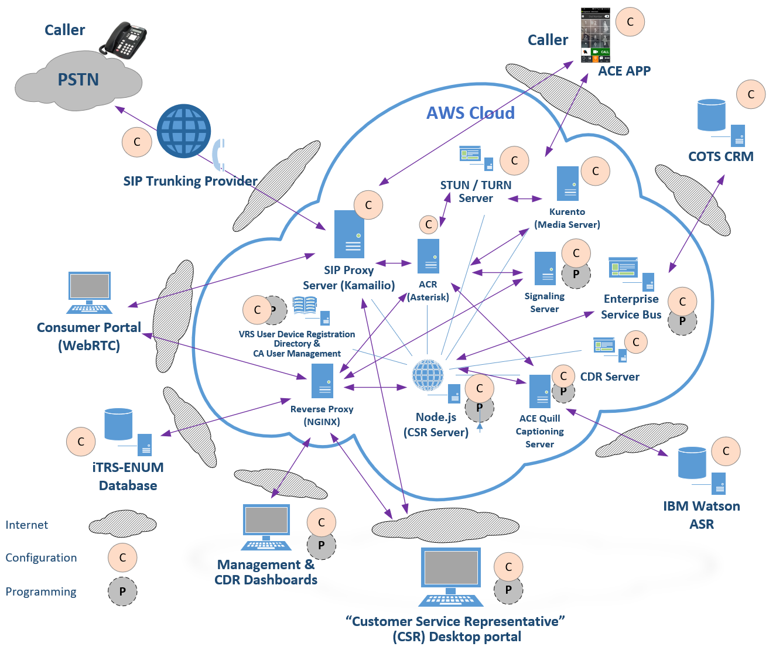

Figure 1. Notional Diagram for ACE Direct Platform

As Figure 1 shows, some ACE Direct components require only configurations (noted as “C”) and other components require both configuration and programming (noted as “P”). Table 1 presents an overview of these components. Table 1 provides a listing and description of the major components in ACE Direct. Please refer to the *ACE Direct Installation and Configuration Guide* for detailed information about installation and configuration.

Table 1. ACE Direct Components

| Component | Description |
| --- | --- |
| Agent Portal | The Agent Portal provides a user interface to the Agent—the Customer Service Representative (CSR)—for login and conducting DVC services to the ACE Direct Consumers. |
| Asterisk Open Source PBX (Private Branch Exchange) | The Asterisk Open Source PBX supports direct video communication via both Public Switched Telephone Network (PSTN) and video calls. |
| Captioning Server | The ACE Quill captioning server provides the interface to web-based captioning services and provides speech to text capabilities for both the Agent and Consumer portals. |
| Commercial Off-the-Shelf (COTS) Customer Relationship Management (CRM) | To demonstrate integration with a CRM service, ACE Direct connects to the Zendesk Representational State Transfer (RESTful) application programming interface (API) via the Enterprise Service Bus. ACE Direct sends Java Script Object Notation (JSON)-based messages to the RESTful Zendesk API to manage and query customer records. |
| Enterprise Service Bus (ESB) | The ESB provides a generic method to update legacy database systems as well as the diverse number of databases and unstructured data repositories on the market and in use today. ACE Direct ESB integrates with a COTS CRM service (e.g., Zendesk) as a ticketing system for the Agent to document service cases. |
| External Visual Ring Indicator and Agent Status | The Kuando Busylight™ is used as an external visual ring indicator and Agent status instrument. ACE Direct supports both of its models, Alpha and Omega. |
| Identity and Access Management | ACE Direct uses the OpenAM and OpenIDM components from ForgeRock to:   * Provide secure access to the Agent and Management portals * Allow self-help features, such as registration and lost password * Allow a Manager to set the hours an Agent can be active in the system |
| iTRS-ENUM database | The iTRS (Interstate Telecommunications Relay Service) database maps 10-digit U.S. telephone numbers to IP addresses using the industry-standard ENUM (E.164 Number to Uniform Resource Identifier (URI) Mapping) protocol. VRS providers assign these 10-digit telephone numbers to their customers. |
| Kamailio SIP Proxy Server | The Kamailio SIP (Session Initiation Protocol) Proxy server provides a single point of entry following Defense-in-Depth principles to create a layer between the ACE Direct environment and the Internet. This enhanced security provides a means to mitigate certain exploits and Distributed Denial of Service attacks (DDoS). |
| Management Portal | The Management Dashboard provides Key Performance Indicators (KPI) that the call center manager can monitor in real time. The Call Detail Record (CDR) Dashboard provides the view and export functions of the Asterisk CDRs stored in its MySQL database. |
| Media Server | The Kurento media server enhances voice, video, and data communication. It also provides advanced calling features such as multiparty calling, screen recording, and more. |
| Node.js | Node.js is an open source platform that can be used to develop applications and servers. For ACE Direct, the Node.js server contains several services running on ports to support the Agent Portal and other management-related portals, including the Management Dashboard and Call Detail Record (CDR) Dashboard. The Node.js server supports the Real-Time Text (RTT) between the Agent Portal and the Consumer Portal. It also provides services for VRS lookup to verify that the phone number is a valid number in the VRS database. |
| Reverse Proxy, Load-balancer, and HyperText Transfer Protocol (HTTP) Cache | NGINX is used as a reverse proxy to only expose HyperText Transfer Protocol Secure (HTTPS) / port 443 and hide internal port number and internal script names to prevent spoofing and hacking by external entities. |
| Consumer Help Center | The Consumer Portal combines form submission with real-time audio, video, and text communication to an Agent. |
| State Management and Key Information Storage | Redis is an in-memory, key-value data storage. It is used as a database to store data previously stored in memory to manage state. |
| STUN Server | STUN (formerly Simple Traversal of UDP through Network Address Translation (NAT) Request for Comment (RFC) 3489) is reflexive and identifies if the endpoint is behind a NAT or firewall and determines the public IP address. This helps STUN establish a peer-to-peer connection. |

## ACE Direct Components and Technology Features

The following subsections recount the development history of ACE Direct and the features in its components. Table 2 shows, by version number and release date, the history of ACE Direct and the features added to each version.

Table 2. ACE Direct Version History

| Version | Release Date | Enhancements / Features Introduced |
| --- | --- | --- |
| 1.0 | November 4, 2016 | * The first open source, omnichannel, auto call-routing contact center platform designed for 2 to 20 Agents * Browser-based interface allowing for remote use by Agents and Managers * A Management Portal for contact center statistics such as calls waiting, calls abandoned, and average hold time * Video, audio, and Real-Time Text communications * Web Real-Time Communications (WebRTC) technology to facilitate browser-to-browser video communication * Enterprise Service Bus for enterprise data integration * Support for multiple queues: Complaints and General Questions |
| 1.1 | February 17, 2017 | * Call transfer functionality from one Agent to another * Increased character limit in WebRTC RTT implementation * Acceptance of inbound PSTN calls * Data transmission encryption using TLS and HTTPS throughout the platform * Segmentation of application servers to increase system scalability * Code modifications to improve reliability and scalability |
| 2.0 | November 1, 2017 | * Introduced a “single pane of glass” for the Agent Portal, ensuring all communications occur through the browser * Enhanced system security through: * An identity and access management solution, OpenAM, to manage system access * URL masking using NGINX to prevent external cyberattacks * Added an external visual ring indicator (Kuando Busylight™) to inform the Agent of an incoming call and others of an Agent’s status * Introduced videomail recording and retrieval * Provided usability enhancements to the Agent, Management, and Consumer portals * Simplified the installation process for quicker installations |
| 2.1 | May 2018 | * Added capability for Managers to modify the contact center’s hours of operations * Added function for a Manager to close the contact center in case of emergency * Integration with Zendesk using CDC Software. This will be a permanent feature and is configurable during installation. * Developed ACE Direct skinny modes for both the Agent and Consumer screens when a separate CRM system is in use * Established outbound calling from the Agent Portal * User Interface (UI) Enhancements: * Present the Agent’s name to Consumer during a call * Re-style the back button on the Consumer Portal * New dialog to inform Consumers that they are in queue * Clear / enable / disable chat using context (both Agent and Consumers) * Agent option to Return to Away / Return to Ready after a call * Enhancements to the Management Portal UI, including the Agent PIE chart, etc. * Incorporated resizable / movable / profile-able Agent forms * Improved Installation and Operations * Global configuration file to simplify the installation process * Updated installation procedure for global configuration * Consolidated database for both ACE Direct and Asterisk * Created an ACE Direct sample database (DB) (script) for an initial installation * Redesigned ACE Direct / NGINX / OpenAM routing for simplicity and HTTP Strict Transfer Security (HSTS) directive |
| 3.0 | October 26, 2018 | * **Containers** – Containers simplify the overall ACE Direct installation, configuration, and deployment. They improve portability to different environments and add modularity. * **Management Portal Agent Provisioning UI** – The Management Portal Agent Provisioning screen makes it easy for call center managers to provision and maintain agent users in both OpenAM and ACE Direct. This allows customization of the default agent accounts. * **Data Logger Utility** – The Data Logger Utility captures and saves log files, trace information, and testing details automatically. This information facilitates troubleshooting interoperability and call quality issues * **NGINX Custom Error Page** – The NGINX Custom Error Page is a more user-friendly page than the default NGINX error page. This ACE Direct page appears when the system is offline * **ASL Video On Hold** – This feature allows the call center to display or advertise a custom message to a caller while on hold or after hours * **Customizable ACE Direct URLs** – Customizable ACE Direct Uniform Resource Locators (URL) allow owners, like the FCC, to customize the public URLs to match their corporate name or brand. An example is <https://xyzcorp.org/XYZDirect/agent> |
| 3.1 | April 9, 2019 | * **SIP Proxy Server** – The SIP Proxy server provides a single point of entry following Defense-in-Depth principles to create a layer between the ACE Direct environment and the Internet. This enhanced security provides a means to mitigate certain exploits and Distributed Denial of Service attacks (DDoS). |
| 4.0 | May 20, 2020 | * **Captioning** – Automated Speech Recognition (ASR) engine speech-to-text captioning is now available in the Consumer and Agent portals. * **WebRTC Media Server** – ACE Direct now uses a Kurento WebRTC Media Server to enhance and improve ACE Direct’s voice, video, and data capabilities. * **Videomail Enhancement** – The media server implements higher-quality videomail recordings, Interactive Video and Voice Response, and a countdown timer. * **Containerization** – Open AM and Asterisk are now available as Docker containers. * **Agent, Consumer, and Management Portal UI Enhancements** – The web portals have better aspect ratios for video, element locations, element placement, and button sizing. * **Captioning Demo Capability** – ACE Direct now has a captioning preview feature that plays a mock captioning conversation between a Consumer and an Agent. This feature is for demonstration purposes only. * **Multi-Party Calling** – ACE Direct Agents and Consumers are able to participate in calls with up to four simultaneous callers on the same call. |
| 4.0 | May 20, 2020 | * **Screen Sharing** – ACE Direct users allow the caller to share their screen with another caller. * **File Sharing** – ACE Direct allow users to share / transfer files from one user to another. |

Table 3 provides a description of the major features in ACE Direct.

Table 3. ACE Direct Features

| Feature | Feature Description |
| --- | --- |
| **Agent Portal** – The Agent interface to the Consumer | * Browser-based to allow for remote access * Data transmission is encrypted using TLS and HTTPS * All video and RTT communications conducted through a single browser * Video display can be set to full screen on command. This is particularly useful when video communication is less than ideal. * Outbound calling using an integrated dialer * Videomails can be viewed and the display sorted on any data fields listed * Videomail callbacks can be made with the click of the mouse * Number of unread videomails displayed * Get Help feature to contact a Manager * External visual ring indicator to notify the Agent of an incoming call and others when the Agent is in a call * Support for multiple queues: Complaints and General Questions * Displays the number of calls waiting in the queue * Visibility into the status of other Agents. Useful if Agents are geographically disbursed. * Call duration provided to the Agent while in the call * CRM ticket information and scripts can be integrated into ACE Direct and displayed in the Agent Portal * Sections of the interface can be resized and moved based on Agent preferences * Skinny mode hides CRM forms * Disable chat during calls from provider devices because these devices do not currently provide a chat feature * Speech-to-text captioning and customization * **Multi-Party Calling** – ACE Direct provides the ability for Agents to establish calls with up to four simultaneous callers on the same call. * **Screen Sharing** – ACE Direct will allow Agents to share their screen with Consumers. * **File Sharing** – ACE Direct will allow Agents to share / transfer files from one user to another. |
| **Consumer Portal** – The Consumer interface to the Agent | * Browser-based to allow remote access * Data transmission is encrypted using TLS and HTTPS * All video and RTT communications conducted through a single browser * Video display can be set to full screen on command. This is particularly useful when video communication is less than ideal. * Agent’s name displayed during video and RTT calls to enhance interaction * Displays the Consumer’s position in the queue * Displays a dialog during after-hours operation of the call center * May be a standalone web page or integrated with an existing portal * Skinny mode bypasses CRM ticket input * Videomail capability * Configurable redirect to a specific URL * Speech-to-text captioning and customization * **Multi-Party Calling** – ACE Direct provides the ability for up to four simultaneous callers on the same call. * **Screen Sharing** – ACE Direct allows Agents to share their screen with Consumers. * **File Sharing** – ACE Direct allows Consumers to share / transfer files with Agents. |
| **Management Dashboard** – Provides contact center statistics and KPIs | * Browser based to allow for remote access * Data transmission is encrypted using TLS and HTTPS * Support for multiple queues to direct Customers to the proper Agent * The following KPIs are a summary of ACE Direct call data: * Calls Waiting – Total number of calls waiting. * Calls Handled – Total number of calls completed. * Average Hold Time (minutes:seconds) – Average call holding. * Calls Abandoned – Number of calls not answered in all queues. * **Queue-related KPIs** – The following KPIs are displayed per queue template: (Logged In – Number of Agents currently logged into the system. * Available Agents – Number of Agents currently in a ready state. * Current Calls – Number of calls currently in progress. * Total Calls – Total number of calls made. * Calls Handled – Total number of calls answered by an Agent. * Calls Abandoned – Total number of calls abandoned. * Talk Time – Average talk time (minutes:seconds). * Hold Time – Average hold time (minutes:seconds). * Longest Hold Time – The longest hold (minutes:seconds). * **Agent-related KPIs** –The Agent name, extension, and registered queues are displayed along with the KPI. The following KPIs are displayed per Agent: * Agent name – Name of the Agent. * Registered extension – Extension assigned to the Agent. * Registered queues – Asterisk queues assigned to the Agent. All queue names are displayed if an Agent is assigned to more than one queue. |
|  | * Calls Completed – Number of calls handled (answered and completed) by the Agent. * Average Call Time – Talk Time divided by number of calls. * Talk Time – The cumulative time the Agent has spent on calls. * Status – Logged Off, Ready, Away, or In-Call. |
| **Call Detail Record Dashboard** – Provides a means of auditing call activity, tracking a call Agent’s activity, and creating a report of both incoming and outgoing calls | * Provides a method to view, sort, search, and export the Asterisk call detail records stored in the database for additional reporting by your business intelligence or report writing tool |
| **Kuando Busylight™ Configuration** – Provides a GUI to customize the light display of the Kuando Busylight™ | * Agent statuses, light colors, and light behaviors (solid / blinking) are customizable to fit your environment * Function to reset to a default configuration * Color / behavior changes are applied to the Agent Portal automatically in real time |
| **Hours of Operation UI** – A feature to implement and manage call center hours of operation | * This UI allows the Manager to establish the days and hours of operation for the contact center instead of having the Asterisk administrator perform this operation through an Asterisk command line * Ability to force open, force close, or resume normal business operation with the click of the mouse * Lists hours of operation in all U.S. time zones for easy readability * Time zone graphical map * Contact center open / closed indicator for a quick view of the contact center status |
| **Videomail Dashboard** – A Manager view of all videomails in the system | * Sort, view, and filter videomails to organize them to the Manager’s preferences * Pie chart for videomail statuses for easy viewing |

## Highlighted User Stories

The FCC and the Health FFRDC partnered with federal agencies to derive typical requests for services and call center workflows. The Health FFRDC built ACE Direct to encompass the core functions of a traditional hearing-based call center. ACE Direct focuses on the responsibilities of Agents and their Managers. Table 4 presents a summary of ACE Direct user stories, which demonstrate these functions and capabilities.

Table 4. Highlighted User Stories for ACE Direct

| User Story | Description |
| --- | --- |
| Inbound Call: Direct Video Call to an ASL-fluent Agent | As an ASL user, I want to speak with an ASL Agent when I contact a call center. |
| Outbound Call: Direct Video Call from an ASL-fluent Agent | As an ASL user, I want to receive a call from a call center ASL Agent. |
| CRM Integration | As an Agent, I want to view, update, and enter new information regarding contact with the Consumer from the corporate CRM system. |
| Call Script Integration | As an Agent, I want to view corporate call scripts based on the needs of the Consumer. |
| Call-handling capabilities | As an Agent, I want to perform “Call on Hold”, “Call Transfer”, “Mute Video”, “Mute Audio”, “Video Privacy”, and “Call Disconnect”, as needed. |
| Consumer Help Center | (A complaint process illustrates this story.) As an Agency, I want a Consumer to file a complaint through a web portal on my website. I also want the option of conversing with the Consumer through video and Real-Time Text. Please refer to subsection 2.6 for details. |
| Videomail | As an Agent, I want to retrieve a videomail left by Consumers. |
| Management Dashboard | As the Manager / Operator, I want to access near real-time information on the dashboard. |
| Call Detail Record | As the Administrator, I want to access the Call Detail Record through a web portal and export CDRs as needed for audit purposes. Please refer to subsection 2.7.2 for details. |
| Web-based Application | As an Agent, I want the ability to work remotely from any location with Internet access. |
| Multi-CSR Login with Status | As an Agent, I want to log in using the Agent Desktop along with other Agents and I want to change my status between “Ready” and “Away”. |
| Add, Suspend, or Remove an Agent’s Access | As the Administrator, I want to add, suspend, or remove an Agent’s access to ACE Direct. |
| Captioning in the Agent Portal | As an Agent, I want to view and customize speech-to-text captions from a Consumer. |
| Captioning in the Consumer Portal | As a Consumer, I want to view and customize speech-to-text captions from an Agent. |
| Multi-Party Calling | As an Agent, I want the ability to video conference with a maximum of four simultaneous callers ( three Agents and one Consumer) on the same call. |
| Screen Sharing | As an Agent, I want the ability to share screen with another ACE Direct caller. |
| File Sharing | As an Agent, I want the ability to share / transfer files between ACE Direct callers. |

## Agent Desktop

This subsection provides a walkthrough of the Agent Portal, highlighting each of the available functionalities.

At the time of publication, the ACE Direct Agent Portal is compatible with the Chrome browser, which is WebRTC compatible. WebRTC technology allows ACE Direct to present video directly through the browser, eliminating the need for a second monitor and providing a full omnichannel experience for the Agent.

### Logging into ACE Direct

Upon navigating to the portal host URL, a login screen appears as shown in Figure 2. To access the portal, Agents must enter their username and password.

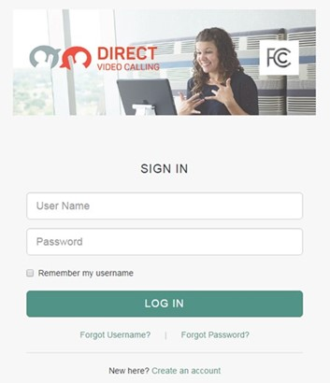

Figure 2. Screenshot of Agent Desktop Login

Figure 3 presents a screenshot of the Agent Desktop, which consists of the following elements:

* Side panels (left and right) to provide navigation and information to the Agent, including a videomail retrieval panel and an outbound calling dial pad
* A user chat area for RTT chats with the VRS Consumer
* A header area that displays call duration information and a help button
* Profile information displaying the Agent’s name and picture and the capability to sign out of the system
* VRS Consumer information such as first name, last name, etc.
* Current CRM ticket information provided by the VRS Consumer

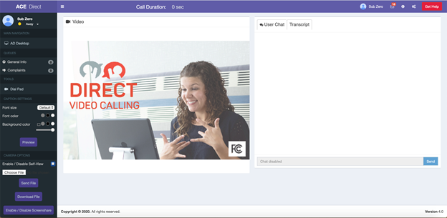

Figure 3. Screenshot of Agent Desktop

### Side Panels

The ACE Direct Agent Portal desktop has two side panels that provide navigation and information to the Agent.

#### Left Side Panel (Main Navigation)

As shown in Figure 4, the left side panel of the Agent Portal provides both Consumer Status and the Main Navigation. Here Agents can select their status as “Ready” or “Away” via the dropdown status change button. When an Agent first signs into the portal, the status defaults to “Away”. When the Agent is ready to receive calls, the Agent selects the “Ready” status. For an incoming call, an intermediate “Incoming Call” status appears, along with a modal alert dialog that takes the foreground. Once the Agent enters a call, the status changes to “In Call”. After the Agent leaves the call, the Agent is presented with a modal to enter either an “Away” or a “Ready” state. If the Agent chooses “Away”, the Agent can perform any tasks related to the call. Selecting the “Ready” state makes the Agent available to Consumers who have entered the call queue.

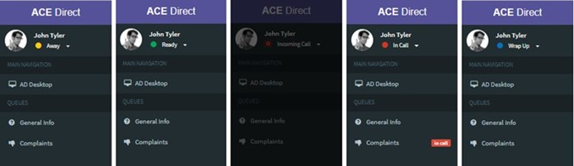

Figure 4. Screenshots of the Agent Statuses

As shown in Figure 5, a new Dial Pad feature at the middle of the left side panel allows Agents to place outbound calls. Clicking the Dial Pad icon brings up the dial pad for outbound calling.

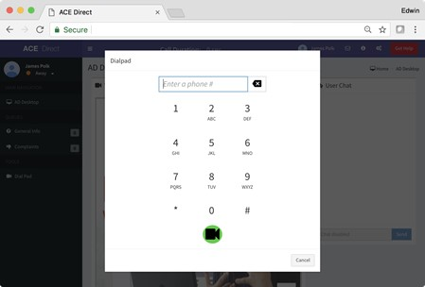

Figure 5. Dialpad for Outbound Calling

Figure 6 is a dialog box found at the bottom left side panel to customize the display of captions. Caption font size, color, and background color can be modified at any time during a call.

Figure 6 presents a screenshot of the Caption Settings as described in the text immediately preceding the figure.

Figure 6. Caption Settings

##### Agent Multi-Party Call

From the Agent Portal, Agents can add multiple parties to a call by clicking on “Multi-Party Invite” from the left bar (as shown in Figure 7). The Agent will then click on the “Dial Pad”, then dial the number of the additional party they wish to include on the call. The Agent can add Consumers and Agents to a Multi-Party call.

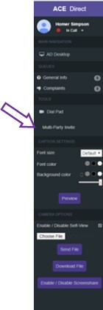

Figure . Screenshot of Agent Option for Multi-Party Call

Figure 8 depicts three Agents and one Consumer in a simultaneous, Multi-Party Call. The consumer will always be displayed in the upper left quadrant of the screen.

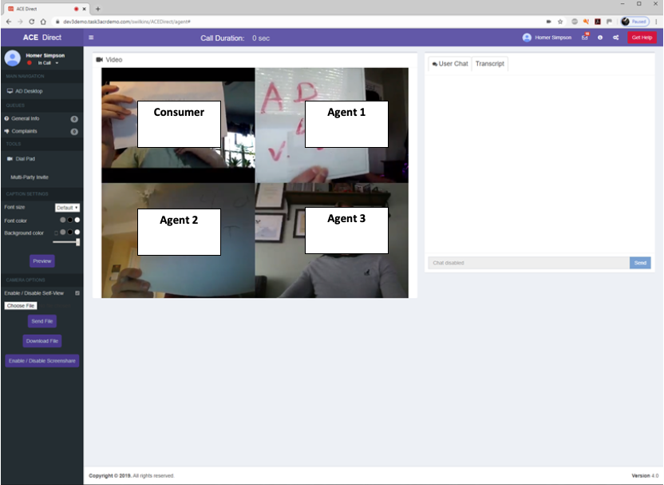

Figure . Screenshot of an Agent Multi-Party Call

##### Agent Screen Sharing

Using the Screen Sharing option, Agents can share their desktop screens with other ACE Direct callers during the call. To do that, the Agent will click on the “Enable/Disable Screenshare” button on the Agent Portal on the left bar (as shown in Figure 9).

Figure 9 presents a screenshot of an Agent Screenshare Option with a right-pointing arrow indicating Enable/Disable Screenshare", as described in the text immediately preceding the figure.

Figure . Screenshot of an Agent Screenshare Option

Figure 10 depicts an Agent who has shared their screen. To discontinue Screensharing, the Agent will click the “Enable/Disable Screenshare” button once again.

Figure 10 presents a screenshot of Agent's Screen Sharing. The bolded, dashed rounded rectangle highlights the image of the Agent's screen as described in the text immediately preceding the figure.

Figure . Screenshot of Agent Screen Sharing

##### Agent File Sharing

Files can be shared between ACE Direct Agents, e.g., Agent to Agent as well as Agent to Consumer.

Agent Sending Files

Files can be shared between ACE Direct Agents, e.g., Agent to Agent as well as Agent to Consumer. From the Agent Portal, the Agent will click on the “Send File”, as shown in Figure 11. The Agent will then click on “Choose File” to select the file they wish to send. Agents can send pictures (e.g., *.png), text (e.g., *.txt), MS Word documents (e.g., *.doc, *.docx), MS Excel files (e.g., *, *.xlsx), MS PowerPoint files (e.g., *.ppt, *.pptx), and Adobe files (e.g., *.pdf). The files cannot be larger than 15MB in size.

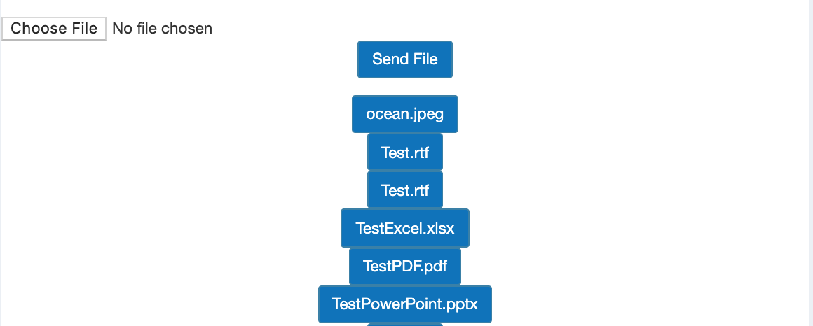

Figure . Screenshot of Agent Sending Files

Agent Downloading Files

Agents can download files they receive from other Agents or from Consumers by clicking the “Download File” button on the Agent Portal, left bar (as shown in Figure 12).

Figure 12 presents a screenshot of an Agent Selecting Download File Option with a right-pointing arrow indicating Download File, as described in the text immediately preceding the figure.

Figure . Screenshot of Agent Selecting Download File Option

The Agent will then click on “Choose File” as shown in Figure 13 to select the file they wish to download. Agents can download pictures (e.g., *.png), text (e.g., *.txt), MS Word documents (e.g., *.doc, *.docx), MS Excel files (e.g., *.xls, *.xlsx), MS PowerPoint files (e.g., *.ppt, *.pptx), and Adobe files (e.g., *.pdf). The files cannot be larger than 15MB in size.

Figure 13 presents a screenshot of  Agent Download File Option with a right-pointing arrow indicating Download File, as described in the text immediately preceding the figure.

Figure . Screenshot of Agent Download File Option

#### Right Side Panel (Agent Status and Videomail Mailbox)

The right-side panel as shown in Figure 14 is accessible by clicking on the gears icon in the top right corner of the portal. The Agent can reach the videomail mailbox directly by clicking on the envelope icon in the top right corner of the portal.

Figure 14 presents a screenshot of the Agent Portal right panel, with a dashed rounded-corner box around the Videomail Mailbox as described in the text immediately preceding the figure.

Figure . Screenshot of Agent Right Panel

This section can be collapsed to give the Agent more space for the main content area. By opening the right-side panel, the Agent can access two tabbed content areas (Agents and Video Mail) as depicted in Figure 15.

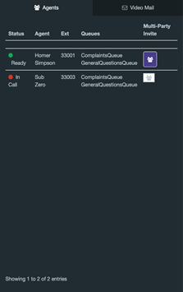

Figure 15. Screenshot of Agent Status

##### Agent Status

The Agent Status section provides the Agent with a list of Agents logged into ACE Direct. The Agent can view information about each Agent listed, such as their status, extension, and queues as noted in Figure 14.

##### Videomail

The Videomail tab, as shown in Figure 16, displays a list of videomails received while the Agents were unavailable to take calls. This list provides the Agent with the videophone number, time, date, duration, and status of the videomail. The Agent can sort the videomail table by any of the columns in ascending or descending order and can filter the videomail by status. The status may be “Unread”, “Read”, “In Progress”, or “Closed”. Unread videomails are highlighted in **boldface**. An indicator at the top right of the screen provides the Agent with a count of unread videomails. Because videomails are not specific to an Agent, all Agents are presented with the same list of videomails.

Figure 16 presents a screenshot of the Agent Videomail Mailbox indicated by the dashed rounded-corner box as described in the text immediately preceding the figure.

Figure . Screenshot of Agent Videomail Mailbox

By clicking on a specific videomail, the Agent can view the contents and update the status. Figure 17 displays the playback screen.

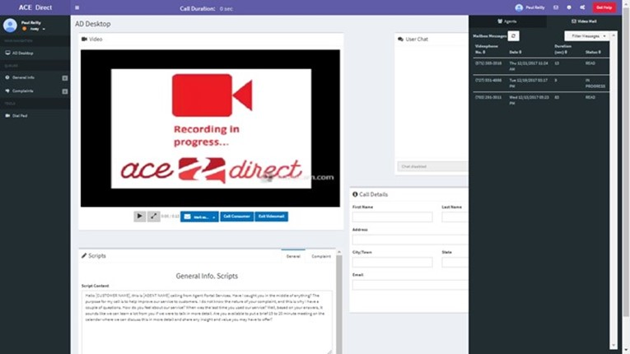

Figure . Screenshot of Videomail Playback

The videomail status can be changed to “Unread”, “Read”, “In Progress, or “Closed”. If the Agent deletes the videomail, it is removed from the videomail mailbox but can be reviewed in the Management Portal before permanent deletion. The Agent can also place a call to the videophone number associated with the videomail.

### Video and Real-Time Text Communications

The ACE Direct platform supports the following methods of communication: voice, video, Real-Time Text, and captioning. This subsection focuses on video and Real-Time Text.

#### Agent Video Chat

Video Chat communications on the platform occur through the browser using WebRTC technology. If the Consumer is using a computer or smartphone, the Consumer must use a WebRTC-compatible browser to enable this functionality. Video Chat can also be used with a videophone. During a call, the Agent has button options to mute audio, mute video, or view the Consumer’s video in full screen mode. Figure 18 shows the video of the Consumer taking up the full screen while the Agent’s self-video remains in the upper right corner.



Figure . Screenshot of Full Screen Video Mode

#### Agent Portal Captioning

ACE Direct generates captions of user conversations and displays the text overlaid on the video screen. The caption text displayed on the Agent Portal shows captions corresponding to the words spoken by the Consumer. Caption text attributes such as size, text color, and background color can be dynamically changed using the caption settings/controls. Figure 19 shows a screenshot sample of captioning in the Agent Portal.

Figure 19 depicts a screenshot of sample captioning on the Agent Portal as indicated by the dashed, rounded-corner box around the caption text with a left upward-pointing arrow as described in the text immediately preceding the figure.

Figure .Screenshot of Sample Captioning on the Agent Portal

#### Real-Time Text Chat

The User Chat box, as shown in Figure 20, provides the Agent another channel of communication with the Consumer. As the Agent types a message to the Consumer in the input field, the Consumer will view the message in real time. The chat history remains visible to the Agent until the Agent closes the ticket. Use of this feature is not available for videophones as of this publication.

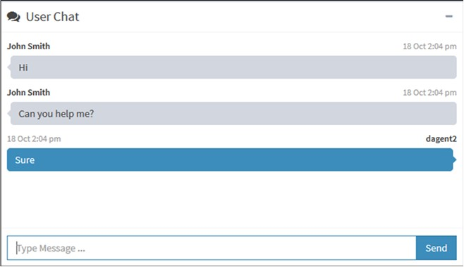

Figure . Screenshot of User Chat Box

### Agent Portal Header

The Agent Portal header provides the Agent with the call duration information, a help button, and profile information about the Agent along with the capability to sign out of the system.

#### Call Duration and Get Help Button

The Call Duration located in center section of the top header shows a running clock of the call length once the Agent accepts the incoming Consumer call. As shown in Figure 21, the Get Help button allows the Agent to request help from a Manager during a call. When the Agent clicks the Get Help button, the Agent’s name will change color and begin to flash on the Management Dashboard to indicate the Agent needs help.

Figure 21 presents a screenshot showing call duration and the assistance button (highlighted by a dashed rounded-border box as described in the text immediately preceding the figure.

Figure . Screenshot of Call Duration and Assistance Button

#### Agent Profile

After logging in, the Agent’s name and picture will appear in the Agent Profile at the top right corner of the Agent Portal head as shown in Figure 22 (As a default, all Agents display the same profile picture.) The Agent has the capability to log out of the ACE Direct Portal by clicking the “Sign out” button. If the Agent has changed the layout of the Agent Portal, it can be reverted to the original layout by clicking the “Default Layout” button.

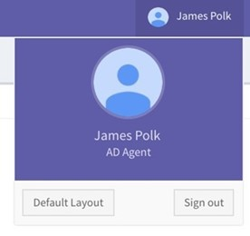

Figure . Screenshot of Agent Profile

### Video Relay Service

#### Video Relay Service Information

The VRS Information section displays information about the Consumer currently on file in the CRM system. Figure 23 shows that after the call has ended, the Agent must click on the “Save” button in the VRS Information box to return to the queue and receive new calls.

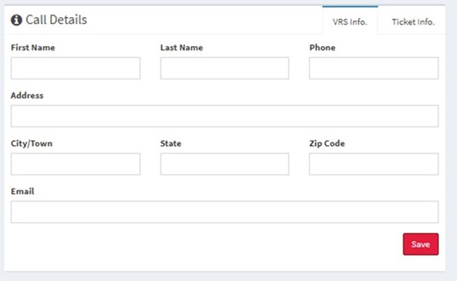

Figure . Screenshot of VRS Information

## Kuando Busylight™ Visual Ring Indicator and Agent Status

ACE Direct incorporates the Kuando Busylight™ device as an integral part for notifying call center personnel of incoming calls and the status of an Agent (such as “Away”, “Ready”, “In call,” etc.). The Administrator can configure the color of the light and ensure a consistent configuration across all Agents. Subsection 2.7.2 presents an example configuration.

The Kuando Busylight™ is not included with the ACE Direct platform and must be purchased separately. The Kuando Busylight™ is available in several different models and from several online vendors.

### Agent Status

Each Agent has a status based on the Agent’s activity with ACE Direct, as shown in Table 5.

Table 5. Agent Status

| Agent Status | Definition |
| --- | --- |
| Away | The Agent is not available, and no calls will be directed to them. |
| Ready | The Agent is available to take calls from the queues. |
| In a Call | The Agent is currently handling a call. |
| Incoming Call | The Agent is receiving a call but has not yet answered it. |
| Wrap Up | The Agent just finished a call but has not yet hit” Return to Ready” or “Return to Away”. No calls can be directed to the Agent. |

The Agent Status, presented by coordinated color and lighting pattern, is communicated via the Kuando Busylight™ device and displayed in the Agent Portal as described in subsection 2.7.2. Figure 24 shows the definitions correlated with the different colors available. The configurations can be reset to the default values at any time by clicking “Reset to Default” in Figure 24.

### Kuando Busylight™ Light Configuration

Managers can customize the color associated with each possible Agent status through the Light Configuration page in the Management Portal as shown in Figure 24. Soon after a Manager saves the form, the color is updated in real time and appears on the Agent’s Kuando Busylight™ as well as in the Agent Portal, as shown in Figure 24 and Figure 25.

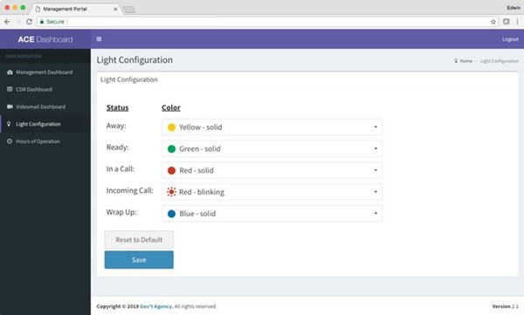

Figure . Screenshot of Kuando Busylight™ Light Configuration Page

Figure 25 shows the default color scheme, which is Section 508 compliant. Using the “Reset to Default” button, the status and color selections will revert to the default settings.

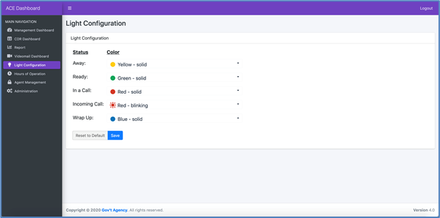

Figure . Screenshot of Kuando Busylight™ Default Color Scheme

### Lightserver

Lightserver is a standalone Electron application that must execute on the Agent’s desktop computer. (A Kuando Busylight™ device must be connected to a USB port on the same computer before starting the Electron application.) The Lightserver program is a graphical user interface (GUI) for integrating the Kuando Busylight™ with the ACE Direct platform. It provides a RESTful interface via localhost only to the Agent Portal. When the Agent status changes, the Agent Portal makes RESTful calls to the Lightserver program.

The ACE Direct Portal makes the initial connection to Lightserver when the Agent navigates to the ACE Direct Agent Portal. This connection enables all requests from the ACE Direct Agent Portal to Lightserver, as shown in Figure 26.

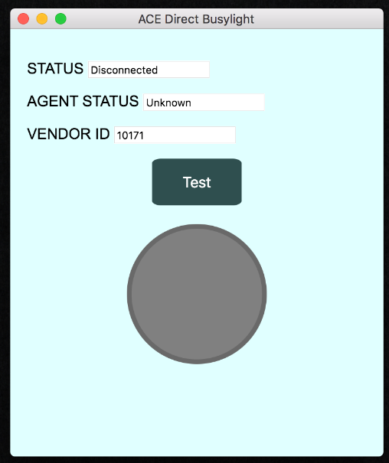

Figure . Lightserver GUI

At startup, the Lightserver GUI attempts to detect a connected Busylight™ device, perform a self-test, and start its server. At this point, an ACE Direct Agent may connect to the Kuando Busylight™ device from the ACE Direct Agent Portal. The Lightserver GUI has the data elements shown in Table 6.

Table . Lightserver GUI Data Elements

| **Data Element** | **Description** |
| --- | --- |
| Status | The current state of the Lightserver program (e.g., Running, Stopped, …) |
| Agent Status | The status of the connected Agent (e.g., ready, away, in call, …) |
| Vendor | The vendor of the light device; currently only PLENOM is supported |
| Test | Perform a self-test of the connected Busylight™ device |

## Consumer Help Center

The design of the Consumer Help Center, also known as the Consumer Portal, gives Consumers the option to submit information before initiating a call with an Agent. The Consumer uses a web form to submit information to document the complaint.

The following two steps are required to access the Consumer Help Center:

* Start the browser on a machine that can access the Consumer Help Center Node.js server.
* Enter a URL similar to https://<hostname>/ACEDirect/Complaint, where <hostname> is the host name of the ACE Direct server. The exact URL depends on your installation and customization of ACE Direct.

### Submit a Complaint

The descriptions and web forms presented in this subsection demonstrate how to submit Consumer complaints in the ACE Direct system.

#### Verify Videophone Number

Figure 27 shows the opening page of the Consumer Portal (Consumer Help Center). Consumers enter their videophone numbers here. The ACE Direct system validates the videophone number before allowing the Consumer to proceed.

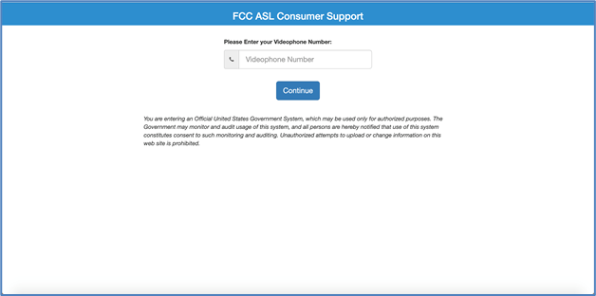

Figure . Screenshot of Consumer Help Center

#### Complete the Consumer Complaint Form

After verifying the videophone number through the iTRS-ENUM database, the portal displays the Consumer Complaint Form, as shown in Figure 28.

If the Consumer had a prior ticket in the CRM system, the videophone number information provided on the previous form is displayed in the VRS Information section via a ticket lookup, as shown in Figure 28. These fields will be empty if this is the Consumer’s first call.

Figure 28 displays a screenshot of the Consumer Complaint Form as described in the text immediately preceding the figure.

Figure . Screenshot of Consumer Complaint Form

#### Consumer Video Chat

After submitting the complaint ticket and receiving a ticket number, the Consumer presses the “Call” button and is connected to an available Agent. Video is the primary form of communication. As shown in Figure 29, the Agent’s video is displayed in the video box in the center of the screen. During a call, the Consumer has button options to mute audio, mute video, or view the Agent’s video in full screen mode.

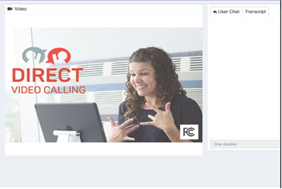

Figure . Screenshot of Video Chat Window

#### Consumer Portal Captioning

ACE Direct generates captions of user conversations and displays the text overlaid on the video screen. The text displayed on the Consumer Portal shows captions corresponding to the words spoken by the Agent. Caption text attributes such as size, text color, and background color can be dynamically changed using the caption settings/controls. Figure 30 shows sample captions on the Consumer Portal in the Caption Settings on the right side of the panel.

Figure 30 presents a screenshot of sample captions on the Consumer Portal as indicated by the dashed rounded-corner box and upward pointing arrow and Caption Settings options as indicated by the downward left-pointing arrow as described in the text immediately preceding the figure. 

Figure . Screenshot of Sample Captions on the Consumer Portal

### Use Real-Time Text Chat

The Agent Chat pane on the right side of the screen provides the Consumer with another channel of communication with the Agent. Notifications appear while the Consumer types a message to the Agent and vice versa. The messages will show up in real time, and the chat history will remain visible until the Agent closes the ticket. As shown in Figure 31, ACE Direct allows a maximum of 500 characters per line during the Agent chat.

Figure 31 shows a screenshot of a Real-Time Text Chat inn the Agent Chat Pane as indicated by the dashed rounded-box and described in the text immediately preceding the figure.

Figure . Screenshot of Real-Time Text Chat

When an Agent becomes available, the video chat will begin. Caption transcripts from the Agent appear in the Transcript tab. After the Consumer or the Agent hangs up, the Consumer is redirected to a page defined during implementation. For the initial configuration, the FCC.gov website is used for the redirect.

### Leave a Videomail

A Consumer may leave a videomail during the Consumer complaint by pressing the “Record” button on the screen as shown in Figure 32. This flow is for illustrative purposes and should be customized to fit the needs of your Consumers.

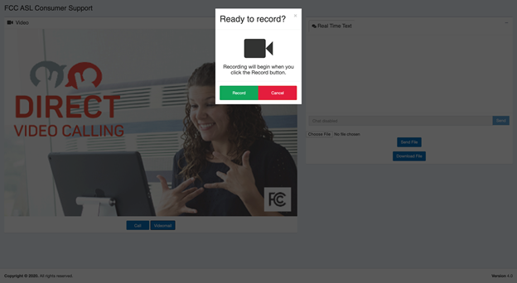

Figure . Screenshot of Ready to Record

Consumers see a self-view during recording. A status bar, which currently defaults to 90 seconds, shows the remaining time for the recording. The maximum videomail length is a configurable parameter. Figure 33 shows the Consumer Portal with a videomail recording in progress.

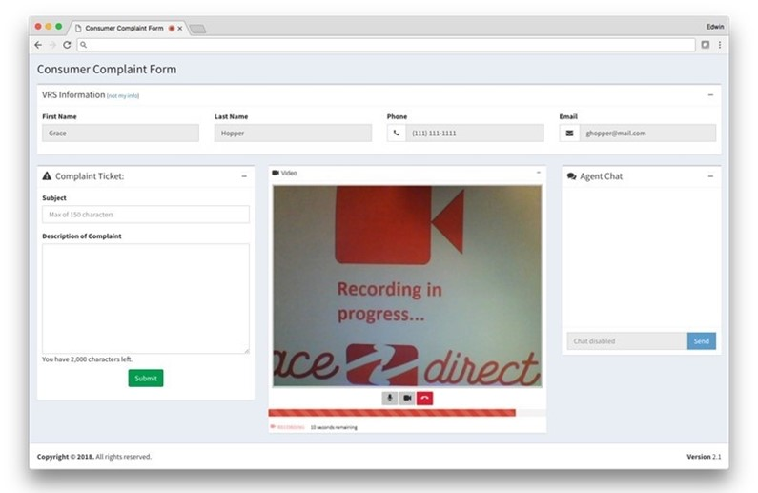

Figure . Screenshot of Videomail Recording in Progress

### Consumer Multi-Party Calls

Consumers can participate in calls with multiple parties connected in the same call. An ACE Direct Agent must initiate all multi-party calls. For more information, please refer to subsection 2.6.2.1.1, Agent Multi-Party Call.

### Consumer Screen Sharing

Consumers can use the Screen Sharing option to share their screens with other ACE Agents during the call, as depicted in Figure 34. The Consumer sends a request to the Agent to initiate the Screen Share function. If the Agent accepts the request, the Screen Share option will initiate on the Consumer’s device.

Figure 34 presents a screenshot of Consumer Screen Sharing as indicated by the dashed, rounded-corner box around the Consumer's screen as described in the text immediately preceding the figure.

Figure . Screenshot of Consumer Screen Sharing

### Consumer File Sharing

ACE Direct supports file sharing between Agents and Customers.

#### Consumer Sending Files

Files can be shared between ACE Direct Agents and Consumers. To send a file, the Consumer clicks on the “Send File” button as shown in Figure 35. The Consumer then clicks the “Choose File” button to select the desired files. Consumers can send pictures (e.g.., *.png), text (e.g., *.txt), MS Word documents (e.g., *.doc, *.docx), MS Excel files (e.g., *.xls, *.xlsx), MS PowerPoint files (e.g., *.ppt, *.pptx), and Adobe files (e.g., *.pdf). The files cannot exceed 15MB in size.

Figure 35 displays a screenshot of Consumer Sending Files with two downward-point arrows indicating (1) Send File and (2) Choose File, as described in the text immediately preceding the figure.

Figure . Screenshot of Consumer Sending Files

#### Consumer Downloading Files

Consumers can download files from other Agents by clicking the “Choose File” button as shown in Figure 36. Consumers can download pictures (e.g.., *.png), text (e.g., *.txt), MS Word documents (e.g., *.doc, *.docx), MS Excel files (e.g., *.xls, *.xlsx), MS PowerPoint files (e.g., *ppt, *.pptx), and Adobe files (e.g., *.pdf). The files cannot exceed 15MB in size.

Figure 36 displays a screenshot of a Consumer downloading files. An upward-pointing arrow indicates the Download File button as described in the text immediately preceding the figure.

Figure . Screenshot of Consumer Downloading Files

## Management Portal

The Management Portal consists of five main components: Management Dashboard, Call Detail Record Dashboard, Videomail Dashboard, Light Configuration page, and Hours of Operation page. These pages present the Manager with information about call center operations, incoming calls, videomail management, customizing colors associated with an Agent status on the Kuando Busylight™ (please refer to subsection 2.7.2), and managing the call center hours of operation.

### Management Dashboard

The Management Dashboard, as shown in Figure 37, provides KPIs for monitoring in real time. Follow these two steps to access the Management Dashboard:

* Start the browser on a machine that can access the Management Portal Node.js server.
* Enter a URL similar to https://<hostname>/ManagementPortal, where <hostname> is the host name of the Management Portal server. The exact URL depends on your installation and customization of ACE Direct.

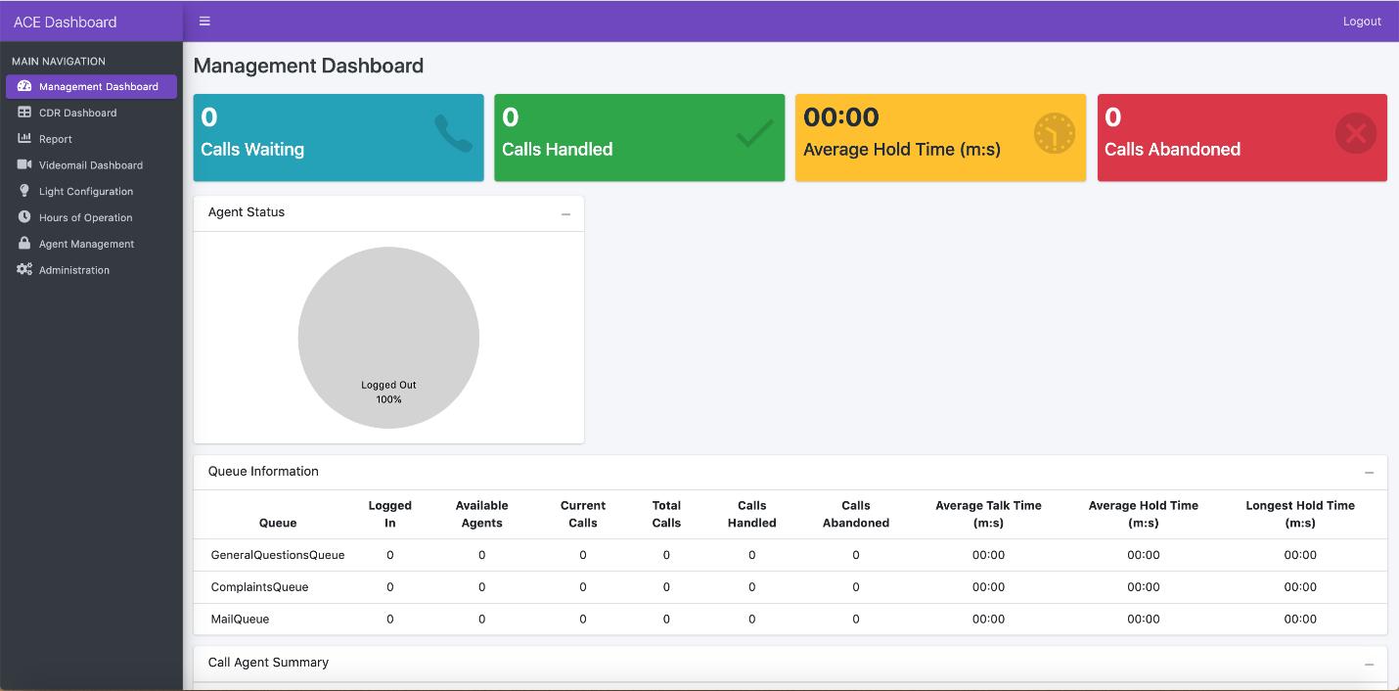

Figure . Screenshot of Management Dashboard

Key Performance Indicator Types

The ACE Direct Management Dashboard presents four types of KPIs:

* **Summary Data** – The following KPIs provide insight into call center status data:
  1. Calls Waiting – Number of calls waiting in all queues.
  2. Calls Handled – Number of calls completed in all queues.
  3. Average Hold Time (minutes:seconds) – Average call holding time in all queues.
  4. Calls Abandoned – Number of calls not answered in all queues.
  5. Average Calls in Queue (chart) – Real-time chart of average calls in queue.
  6. Agent Status (chart) – Real-time chart of agents logged in/out.
* **Queue-related KPIs** **–** The following KPIs are:
  1. Logged In – Number of Agents currently logged into the system.
  2. Available Agents – Number of Agents currently in a ready state.
  3. Current Calls – Number of calls currently in progress.
  4. Total Calls – Total number of calls made.
  5. Calls Handled – Total number of calls answered by an Agent.
  6. Calls Abandoned – Total number of calls abandoned.
  7. Talk Time – Average talk time (minutes:seconds).
  8. Hold Time – Average hold time (minutes:seconds).
  9. Longest Hold Time – The longest hold time (minutes:seconds).
* **Agent-related KPIs** **–** The following KPIs are displayed per Agent. The Agent name, extension, and registered queues are displayed along with the KPI:
  1. Agent Name – Name of the Agent.
  2. Registered Extension – Extension assigned to the Agent.
  3. Registered Queues – Asterisk queues assigned to the Agent. All queue names are displayed if an Agent is assigned to more than one queue.
  4. Calls Completed – Number of calls handled (answered and completed) by the Agent.
  5. Average Call Time – Talk Time divided by number of calls.
  6. Talk Time – The cumulative time the Agent has spent on calls.
  7. Status – Logged Off, Ready, Away, or In-Call.
* **Resource Status KPIs** – The following KPIs denote the resource status:
  1. Resources – A list of services required for ACE Direct to properly operate (ACE Direct, ACR-CDR, Agent Provider, Asterisk, VRS Lookup, and Zendesk).
  2. Status – The current state of each service (Running or Unavailable).

### CDR Dashboard

Asterisk generates an Agent Event when a call is completed. A Call Detail Record (CDR) contains metadata that describes each call, such as the time of the call, call source, and call destination. The CDR Dashboard provides the capability to audit call activity, track an Agent’s call activity, and report on incoming and outgoing calls. The CDR Dashboard facilitates viewing and exporting of Asterisk CDRs stored in the MySQL database.

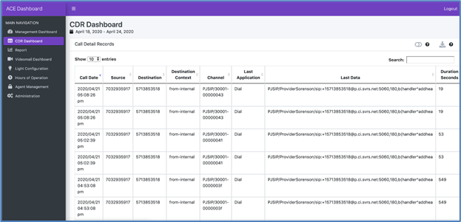

Figure . Screenshot of Call Detail Record

The CDR Dashboard allows the user to perform the following actions on the CDRs:

* **Select Date Range** – The Consumer can select a date range for the report. Predefined values are Today, Yesterday, Last 7 days, Last 30 days, This Month, Last Month, All Time (January 1st, 2016 to Today), and Custom Range. The default selection is “Last 7 Days”.
* **Sort Column** – The Consumer can sort on any column by clicking the sort icon located next to each column name. To multi-sort columns, the Consumer depresses the shift key when selecting columns.
* **Show/Hide Columns** – This action expands / condenses the table to show / hide the following columns: Caller ID Text, Destination Channel, Disposition, AMA Flags, Account Code, User Field, Unique ID, Linked ID, Sequence, and Peer Account.
* **Download CSV File** – This action downloads the table as a Comma Separated Value (CSV) file. The CSV file contains only data within the date range.
* **Search** – The user can search the entire table. Search results are displayed in near real time.

Table 7 presents the Call Detail Record Column Definitions in the CDR table.

Table 7. Call Detail Record Column Definition

| Display Name | Database Column | Description |
| --- | --- | --- |
| Call Date | Calldate | The start datetime of the call. Default format: 2016-09-07T09:35:41Z. The dashboard formats the date to 2016/09/07 09:35:41 pm (adjusted for time zone). |
| Caller ID Text | Clid | The full consumer ID, including the name, of the calling party. This field is set automatically and is read-only. |
| Source | Src | The calling party’s caller ID number. It is set automatically and is read-only. |
| Destination | Dst | The destination extension for the call. This field is set automatically and is read-only. |
| Destination Context | Dcontext | The destination context for the call. This field is set automatically and is read-only. |
| Channel | Channel | The calling party’s channel. This field is set automatically and is read-only. |
| Destination Channel | Dstchannel | The called party’s channel. This field is set automatically and is read-only. |
| Last Application | Lastapp | The last dialplan application that was executed. This field is set automatically and is read-only. |
| Last Data | Lastdata | The arguments passed to the lastapp. This field is set automatically and is read-only. |
| Duration Seconds | Duration | The number of seconds between the start and end times for the call. This field is set automatically and is read-only. |
| Billable Seconds | Billsec | The number of seconds between the answer and end times for the call. This field is set automatically and is read-only. |
| Disposition | Disposition | An indication of what happened to the call. This may be NO ANSWER, FAILED, BUSY, ANSWERED, or UNKNOWN. |
| AMA Flags | Amaflags | The Automatic Message Accounting (AMA) flag associated with this call. This may be one of the following: OMIT, BILLING, DOCUMENTATION, or Unknown. |
| Account Code | accountcode | An account ID. This field is user defined and is empty by default. |
| User Field | Userfield | A general-purpose user field. This field is empty by default and can be set to a user-defined string. |
| Unique ID | Uniqueid | The unique ID for the src channel. This field is set automatically and is read-only. |
| Linked ID | Linkedid | A unique identifier that unites multiple CDR records. |
| Sequence | Sequence | A numeric value that, combined with uniqueid and linkedid, can be used to uniquely identify a single CDR record. |
| Peer Account | peeraccount | The account code of the called party’s channel |

### Videomail Dashboard

The Videomail Dashboard, as shown in Figure 39, allows the Manager to track videomail-related information. It shows all videomails that are present in the Agent Portal, along with the date received, Agent(s) that viewed and processed the videomail, caller videophone number, and videomail status. If an Agent deletes the videomail, the status will show “Marked for Deletion”, at which point the Manager can review it and choose whether to permanently delete it. If the Manager does not delete the videomail, then the videomail is permanently deleted after 14 days.

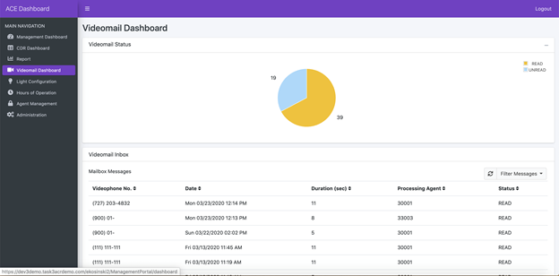

Figure . Screenshot of Videomail Dashboard

### Hours of Operation

The Hours of Operation page, as shown in Figure 40, allows the Manager to control the operating hours of ACE Direct. The page displays the call center hours of operations for each time zone. A Manager can select Open and Close times for the call centers. The Manager also has the option to override the duty hours with an Always Open or Always Closed option. These override options can be used in the case of an emergency closure or holiday. A Consumer who accesses the ACE Direct Consumer Portal after hours will be presented a message advising that the call center is closed.

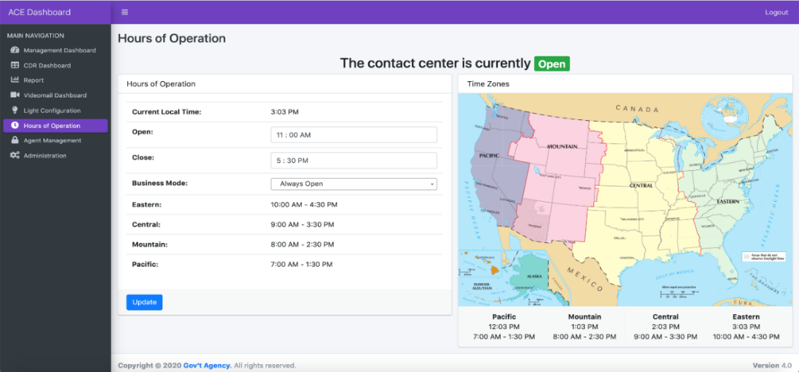

Figure . Screenshot of Hours of Operation Page

### Agent Management

The Agent Management page allows the Manager to add / delete / update Agents. The page can be loaded by selecting “Agent Management” from the side panel of the Management Portal, which lists the existing Agents configured in the system as shown in Figure 41. The Manager may set the number of Agents to be displayed in a single page and sort Agents based on their name, username, and extension assigned.

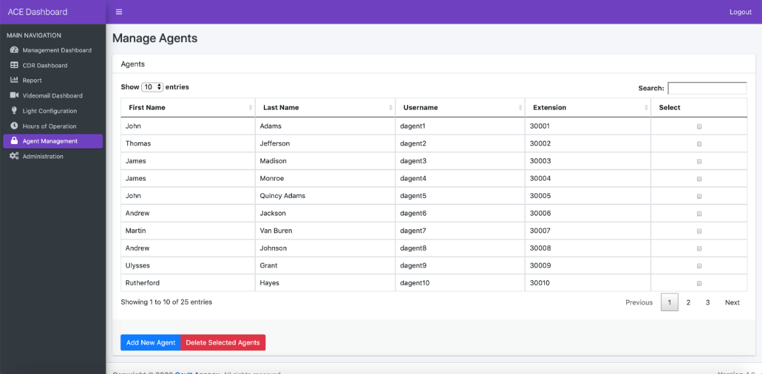

Figure . Screenshot of Agent Management Page

#### Add a New Agent

A Manager can add a new Agent by clicking the “Add New Agent” button at the bottom of the Agent Management page. Figure 42 illustrates the required information for entry. ACE Direct checks the proper data format before a new Agent is created, and the Manager will be prompted to fix any incorrect data input.

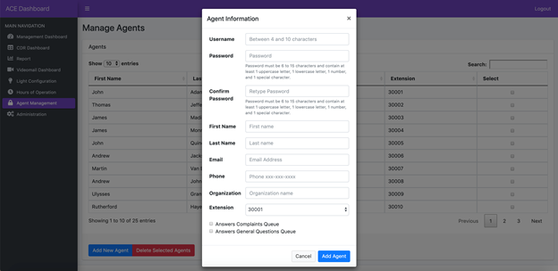

Figure . Screenshot of Add New Agent Popup

#### Update an Existing Agent

A Manager can update the Agent information by clicking on any existing Agent record. Figure 43 illustrates the Agent update popup. Note that Agent username and password are grayed out and not available for updating. The Manager may also delete the Agent record on the same popup.

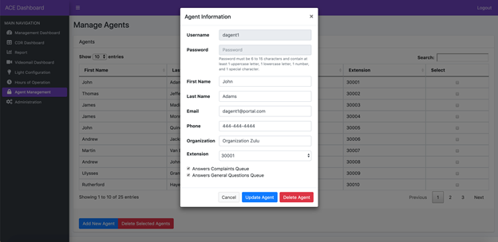

Figure . Screenshot of Update Agent Popup

#### Bulk Delete Selected Agents

The Manager may select a group of Agent records and delete them by first selecting multiple Agents from the “Select” column and then clicking on the “Delete Selected Agent” button at the bottom of the Agent Management page. The system will prompt the user to confirm the deletion as illustrated in Figure 44.

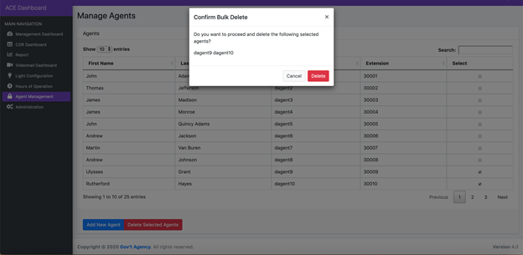

Figure . Screenshot of Agent Bulk Deletion Popup

## Identity and Access Management

ACE Direct integrates with ForgeRock OpenAM, an open source identity and access management enterprise solution that provides user management and access control capabilities. The ForgeRock OpenAM and embedded OpenDJ are the only ForgeRock packages used in ACE Direct.

ACE Direct users, such as Managers and Supervisors, must be provisioned in OpenAM before they can access the Management, Agent, or Consumer portals. To provision Agents, use the Agent management feature on the Management Portal, although the password management functionalities may be used after Agent creation.

Provisioning instructions to create new roles can be found in Provision.md under <https://github.com/FCC/ACEDirect> in the ‘iam’ section.

There are two ways a user authenticates with the Agent or Management portals:

* **ACE Direct URL** – The user accesses ACE Direct directly by entering the ACE Direct URL. If the user is already authenticated with ACE Direct and the session is still valid, the Agent Portal is displayed; if not, the user is redirected to the Main login page to authenticate. The Agent Portal is displayed after a successful login.

**An OpenAM Login URL (Main login page) –** This is the main login page for a user to authenticate, reset the password, or create a new account. After logging in, the user selects the application to access as listed on the dashboard.

The following subsections describe the identity and access management capabilities in detail.

### Login Screen

Figure 45 shows the login screen.

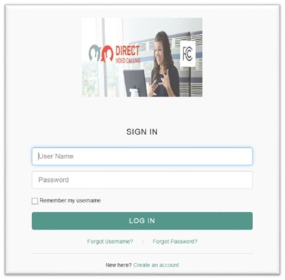

Figure . Screenshot of Login Screen

The login screen consists of the following elements:

* **Login** – User provides login credentials (username, password) to authenticate to ACE Direct.
* **Forgot Username** – Redirects the user to the “Forgot Username” page to retrieve username.
* **Forgot Password** – Redirects the user to the “Forgot Password” page to reset password.

**Self-Registration** – Allows the user to self-register and create an account.

#### Forgot Username

A user clicks the “Forgot Username” link to retrieve a forgotten username. The following “Retrieve Your Username” screen is displayed as shown in Figure 46.

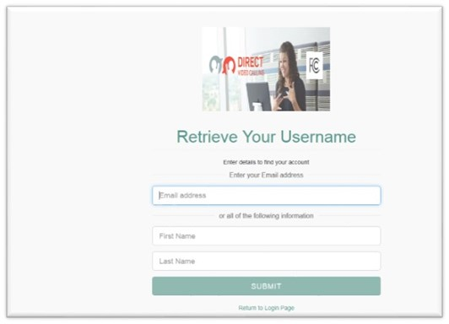

Figure . Screenshot of Retrieve Your Username

A user may retrieve their username via:

* **Email** – If the user entered his / her email on the reset username screen.
* **Answering security questions** – The user is prompted with security questions after he / she submits First Name/Last name on the retrieve username screen. If the user answers the security questions correctly, the screen displays the user’s dashboard.

#### Forgot Password

Figure 47 shows the “Reset Your Password” screen displayed when the user clicks the “Forgot Password” link to reset password.

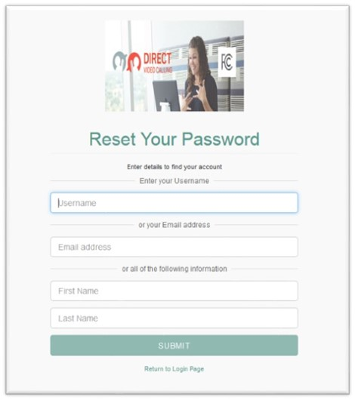

Figure . Screenshot of Reset Your Password

Users may reset the password via:

* **Email** – If the user entered his / her email on the reset password screen.
* **Answering security questions** – The user is prompted with security questions after he / she submits username or First Name/Last name on the reset password screen. If the user answers the security questions correctly, the screen displays the user’s dashboard.

#### Self-Registration

It is recommended that the Administrator use the Agent management feature on the Management Portal to create / update / delete an Agent. Any person can self-register and create an account to become a user; however, that account is not activated until the Administrator activates the user account. To create such a user account, the self-registering person clicks the “Create an account” link at the bottom of the login page as shown in Figure 45. The “Register Your Account” screen will pop up, allowing the new user to enter his or her email address and submit the registration request. An email will be sent to the user’s email address to continue and complete the creation of the account.

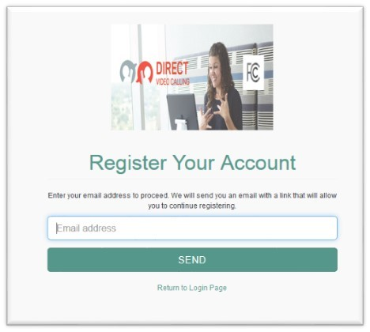

Figure . Screenshot of Register Your Account

### User Dashboard

Figure 49 shows the User Dashboard page after the user is authenticated with the Main login page.

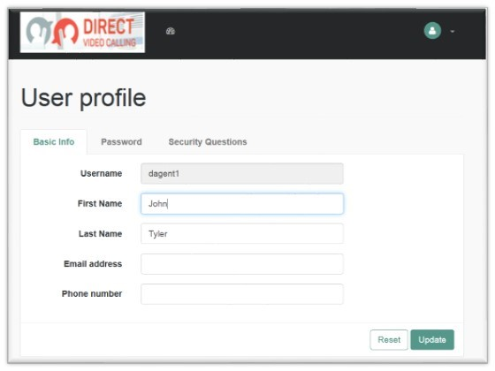

Figure . Screenshot of User Dashboard

The User Dashboard page consists of the following sections:

* User profile
  + Basic Info
  + Password
  + Security Questions
* Dashboard
* Logout

#### User Profile

##### Basic Info

Figure 50 shows the Basic Info tab on the User profile screen.

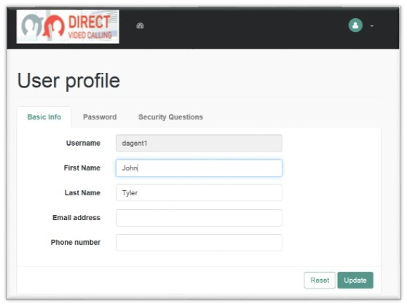

Figure . Screenshot of Basic Info Tab

The user views or updates his / her first name, last name, email address, or phone number on this page, and clicks “Update” to save the changes.

##### Password

Figure 51 shows the Password tab on the User Profile screen. The user updates his or her password from this screen. To change the password, the user clicks on the Password tab and clicks “Update” to save changes.

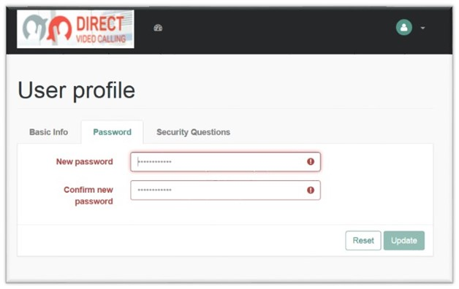

Figure . Screenshot of Update Password Tab

##### Security Questions

Figure 52 shows the Security Questions tab on the User Profile screen. A user may retrieve his / her password via email by answering security questions. This screen allows the user to add security questions to retrieve a forgotten password by email.

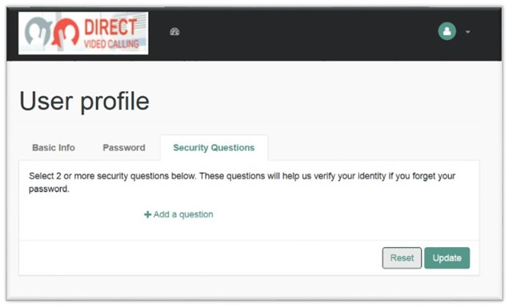

Figure . Screenshot of Security Questions Tab

The user must provide at least two security questions for this purpose. To accomplish this, the user must:

* Select the “Security Questions” tab.
* Select a pre-defined security question or create a new security question.
* Provide an answer to the question.
* Repeat for at least one additional security question.
* Click “Update” to save the changes.

#### Dashboard

The dashboard is an area where the user views the list of applications approved for his / her access. Figure 53 shows an example of an Agent’s dashboard and a list of approved applications under the My Application dropdown.

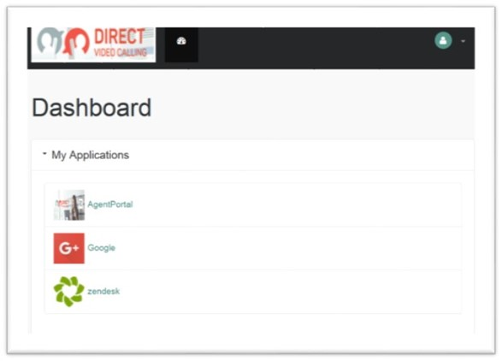

Figure . Screenshot of User Dashboard

#### Logout

To log out from the Main Login page and all open sessions to the Agent and/or Management Portal, select “LOG OUT” from the dropdown list at the top right corner of the page as shown in Figure 54.

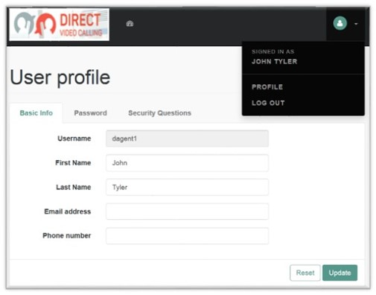

Figure . Screenshot of Logout Screen

## Data Logger

The Data Logger is a web-based tool developed by the MITRE team to support ACE Direct interoperability testing. During each video call, the Data Logger collects data from different sources and presents it to the user on a single web page. Automated data collection in a consistent format removes the burden of data collection from the developers, freeing them to analyze the collected data and focus on a specific issue. Because the Data Logger runs on the Asterisk server, it can capture the Asterisk logs and all the network traffic to and from the Asterisk server.

A test session may consist of one or more video calls, with the collected data categorized either as test session or log data as follows:

* **Test session data**
  + Contains metadata about the debugging session such as username, call start and stop times, etc.
  + Are stored in a MySQL database
* **Log data**
  + Contain a snapshot of the /var/log/asterisk/debug log (with pjsip debugging enabled) covering the duration of the video call(s)
  + Packet capture file (created with tcpdump) containing all incoming and outgoing network traffic
  + Asterisk and packet capture logs are stored in an AWS S3 bucket because of their size

As the analysis proceeds, each testing session generates a matrix—an automatically populated outcome of each testing session. The matrix contains one test session per cell; each cell is color coded red, green, or white, which indicate X, Y, and Z. The matrices help developers to quickly identify which test sessions may need further review.

### Login Screen

The initial installation of the ACE Direct Call Logger on the Asterisk server contains no user account information. The ACE Direct Call Logger will prompt the user to create an initial administrative account. To access the ACE Direct Call Logger, go to http://<Asterisk FQDN>:<Port number>/. shows the screen that appears for the initial use of the ACE Direct Call Logger application.

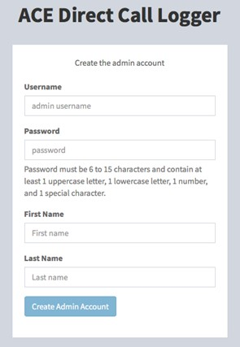

Figure 55. Screenshot of First-Time Login Screen

The first-time login screen consists of the following elements:

* **Username** **–** User provides a username for administrative access.
* **Password** **–** User provides a password that meets criteria for length and complexity.
* **First Name** **–** First name of the user is associated with the administrative account.
* **Last Name** **–** Last name of the user is associated with the administrative account.

**Create Admin Account** **–** Creates an administrative user and stores the account information in the MySQL database.

The first-time login screen will only appear once. Once the administrative account is created, the user will be prompted with the standard login screen shown in Figure 56. The standard login screen consists of the following elements:

* **Username** – User provides a username (administrative or standard user).

**Password** – User provides the corresponding account password.

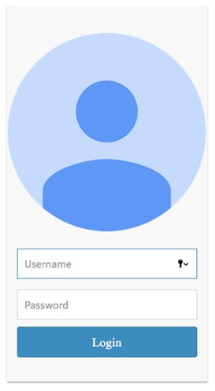

Figure 56. Screenshot of Standard Login Screen

### Session Manager

The next screen that appears after user login is the Session Manager screen. The Session Manager is the main entry point for the Data Logger. Figure 57 presents a screenshot of the Session Manager.

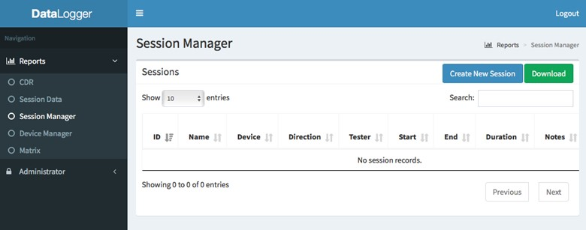

Figure . Screenshot of Session Manager

The navigation panel on the left side of the screen provides the following options:

* **CDR** – Displays the Call Detail Records logged by Asterisk to the MySQL database.
* **Session Data** – Displays information about a specific test session.
* **Session Manager** – Allows the user to create, start, and stop test sessions.
* **Device Manager** – Allows the add to device database to identify the equipment used in each test session.
* **Matrix** – Presents a high-level view of test results that can easily reviewed. Each cell in the matrix can be assigned a color (green, red, white) to allow the developers to quickly identify tests that need additional review.

**Administrator** – Allows the Administrator to manage user accounts.

To create a new logging session, select the “Create New Session” button on the Session Manager page as shown in Figure 58. Note that all gray-shaded input fields are either populated by the system (e.g., test start and end time) or dropdown menus.

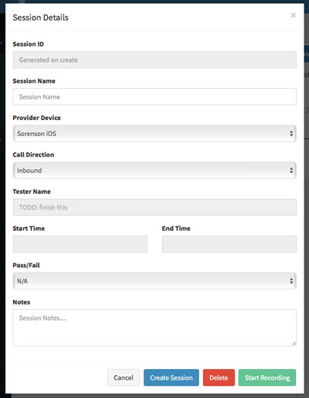

Figure . Screenshot of Session Details Page

The following data are required whenever a session is created:

* **Session ID** **–** A unique session identification number that is auto-generated by the system.
* **Session Name** – User-provided name for this session.
* **Provider Device** – Identifies the provider device. A dropdown menu allows the user to pick a provider and device (e.g., Sorenson iOS, Purple VP2 P70, etc.).
* **Call Direction** – Inbound, outbound, or videomail.
* **Tester Name** – Identifies the tester running the test.
* **Start Time** – System-generated timestamp, identifies the start time of the data logging.
* **End Time** – System-generated timestamp, identifies the end time of the data logging.
* **Pass/Fail** – User-provided input, indicates if the test was successful or not. The selected value is used to color the corresponding session cell in the matrix. Selectable options are N/A, Pass, and Fail.

**Notes** – User-provided input about the test. For example, this could note any issues encountered during the test that could help explain results, test-specific setup, or configuration, etc.

Once the Session Details page has been populated, push the “Start Recording” button to begin the logging session. (**Note:** the button changes to “Stop Recording.”) To stop the recording session, press the “Stop Recording” button. To view the results for the session just recorded, press the “View Results” button; otherwise, press the “Cancel” button to close the Session Details screen.

After a session recording completes, the session will appear as a row in the Session Manager. Figure 59 shows the populated Session Manager screen. Each row is colored based on the Pass/Fail status selected on the Session Details screen.

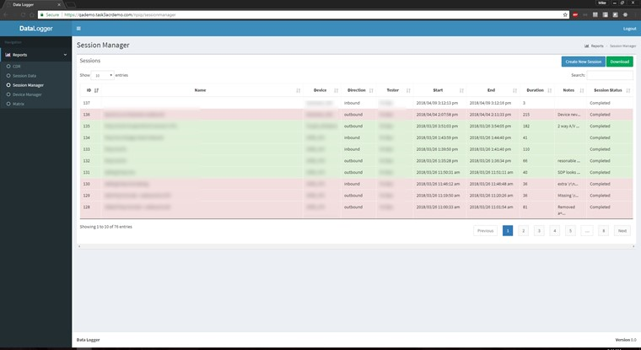

Figure 59. Screenshot of the Populated Session Manager

Click on a row to show specific details about the test and provide download links. Figure 60 shows the detail screen that appears after clicking on a row in the previous table. This screen shows the data provided by the user before the recording began. In addition, this screen contains download links for both the packet capture file (in pcap format) and the Asterisk log file (in text format).

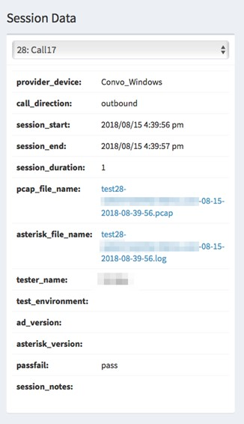

Figure 59. Screenshot of Test Session Details

### Matrix View

The Matrix View provides a high-level view of tests so users can quickly get a status of the collected data (indicated as a pass or a fail). In Figure 61, the screenshot of the Matrix View shows a color-coded outcome for each test session (green, red, or white). Red denotes failures, green denotes passes, and white indicates that a session was created but was not marked pass or fail. Each cell contains the corresponding session ID and timestamp of the session.

There are three matrices defined: inbound calls, outbound calls, and videomail calls. Each matrix has a y-axis representing the different device manufacturers and an x-axis representing device platforms for each manufacturer. Some manufacturers do not have a device for every platform / operating system (OS). For the latter cases (as shown in the figure), the cell is gray and marked with an “N/A”.

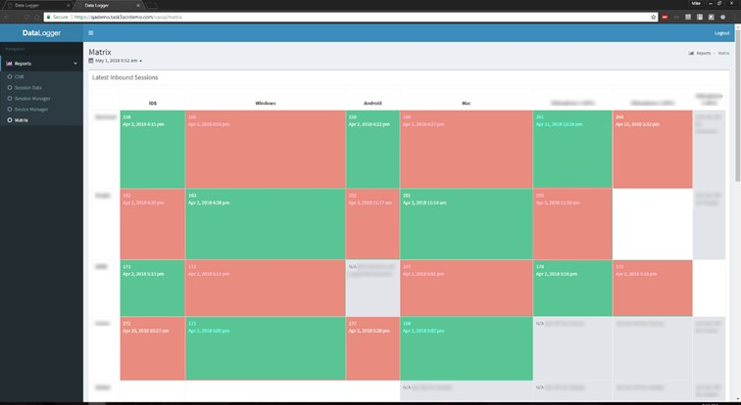

Figure 60. Screenshot of Matrix View

Clicking on a cell brings up detailed information about the selected test. Figure 62 shows an example of the details for a Data Logging Session. In addition to the details about the test, the Session Details screen also includes download links for both the pcap and Asterisk log files.

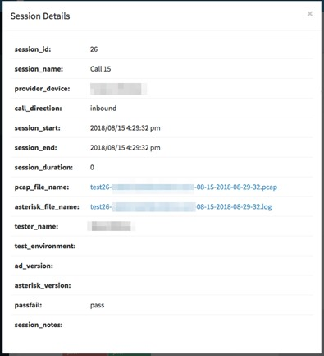

Figure 61. Screenshot of Matrix View Session Details

Acronyms

| Term | Definition |
| --- | --- |
| ACE | Accessible Communications for Everyone |
| ADA | Americans with Disabilities Act |
| AMA | Automatic Message Accounting |
| API | Application Programming Interface |
| ASL | American Sign Language |
| AWS | Amazon Web Services |
| CA | Communication Assistant, Certificate Authority |
| CDR | Call Detail Record |
| CMS | Centers for Medicare & Medicaid Services |
| COE | Center of Expertise |
| COTS | Commercial Off-the-Shelf |
| CRM | Customer Relationship Management |
| CSR | Customer Service Representative |
| CSV | Comma Separated Value |
| DVC | Direct Video Calling |
| EIP | Elastic Internet Protocol |
| ENUM | E.164 Number to URI Mapping |
| ESB | Enterprise Service Bus |
| FCC | Federal Communications Commission |
| FFRDC | Federally Funded Research and Development Center |
| GUI | Graphical User Interface |
| HSTS | HyperText Transfer Protocol Strict Transport Security |
| HTTP | HyperText Transfer Protocol |
| HTTPS | HyperText Transfer Protocol Secure |
| iTRS | Interstate Telecommunications Relay Service |
| IP | Internet Protocol |
| JSON | JavaScript Object Notation |
| KPI | Key Performance Indicator |
| NAT | Network Address Translation |
| **NGINX** | A web server which can also be used as a reverse proxy, load balancer, mail proxy and HTTP cache |
| **OpenAM** | Open Access Management |
| OS | Operating System |
| PBX | Private Branch Exchange |
| POC | Proof of Concept |
| PSTN | Public Switched Telephone Network |
| REST | Representational State Transfer |
| RFC | Request for Comment |
| RTT | Real-Time Text |
| SIP | Session Initiation Protocol |
| SSL | Secure Socket Layer |
| STUN | Session Traversal Utilities for NAT |
| UDP | User Datagram Protocol |
| URI | Uniform Resource Identifier |
| URL | Universal Resource Locator |
| VPN | Virtual Private Network |
| VRS | Video Relay Service |
| WebRTC | Web Real-Time Communication |

Notice

This work was produced for the U. S. Government under Contract Number 75FMC18D0047, and is subject to Federal Acquisition Regulation Clause 52.227-14, Rights in Data—General, Alt. II, III and IV (DEC 2007) [Reference 27.409(a)].

No other use other than that granted to the U. S. Government, or to those acting on behalf of the U. S. Government under that Clause, is authorized without the express written permission of The MITRE Corporation.

For further information, please contact The MITRE Corporation, Contracts Management Office, 7515 Colshire Drive, McLean, VA 22102-7539, (703) 983-6000.

©2020 The MITRE Corporation. All rights reserved.

1. MITRE is using d/Deaf as an umbrella term to describe individuals who are deaf in the audiological sense, as well as those who identify as culturally Deaf.
2. <https://www.fcc.gov/ace>
3. Available at: <https://www.fcc.gov/document/fcc-adds-american-sign-language-consumer-support-line-videophone>.